# Main Landing Page

## Features

Following a successfully login, users will be presented with a main landing page where they can search for review pages of a unit or a lecturer. All results related to the user search inputs will be displayed on the same page, after a fussy search operation is performed. The search results contain a list of hyperlinks to review pages, each of which comes with a description and ratings of the units/lecturers of the page. In addition, an “Ima Lucky” button is provided next to the “Search” button, which on pressed, generates a list of random results.

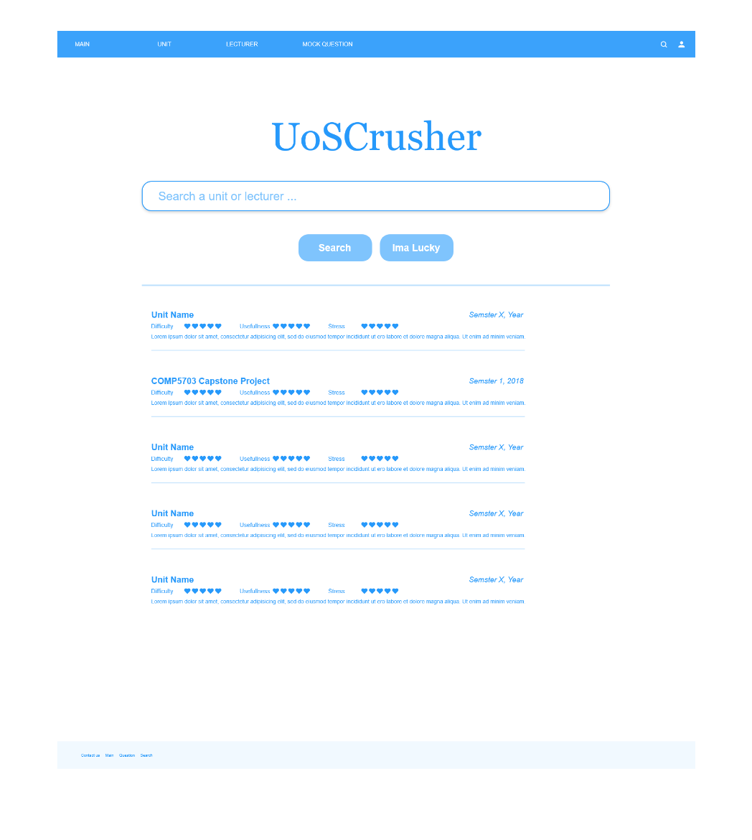

# Unit Review

## Features

One of the core functions of our web application is to let users browse and writer reviews about IT-related units at University of Sydney. The main features of the component are presented as follows:

1. Show key static information of a unit.

The key information is excerpted from CUSP, including short description, lecturer(s), assumed knowledge, etc. We found that CUSP unit description pages might contain too much information, making it difficult for users, especially potential students, to locate the what they need. So instead, we exclude some not-so-relevant data, like attributes and objectives, for the purpose of clarity and simplicity.

1. Show unit reviews.

Reviews of a unit will be displayed orderly. The users can choose to sort the reviews by their creation time, numbers of “upvotes” and so forth. Each review component consists of ratings and a description, as well as buttons allowing the reviewer to modify or delete the review.

1. Allow users write reviews for as well as rate the unit, on a scale of 1 to 5, with respect to the following

* Difficulty: how hard is it to get satisfactory assessment outcomes?
* Stress: measures the workload of the unit with a rating 5 being very stressful.
* Practicality: describes how well a unit prepares the reviewer for job hunting.

For instance, suppose COMP5347 were difficult, not stressful and very useful, a user would rate it 5, 3 and 5 respectively.

1. Allow users to edit and delete their reviews.

On the page, users can only modify and delete their own reviews. In other words, “Edit” and “Delete” button of a review will not be visible to the current user, if the review was made by other users.

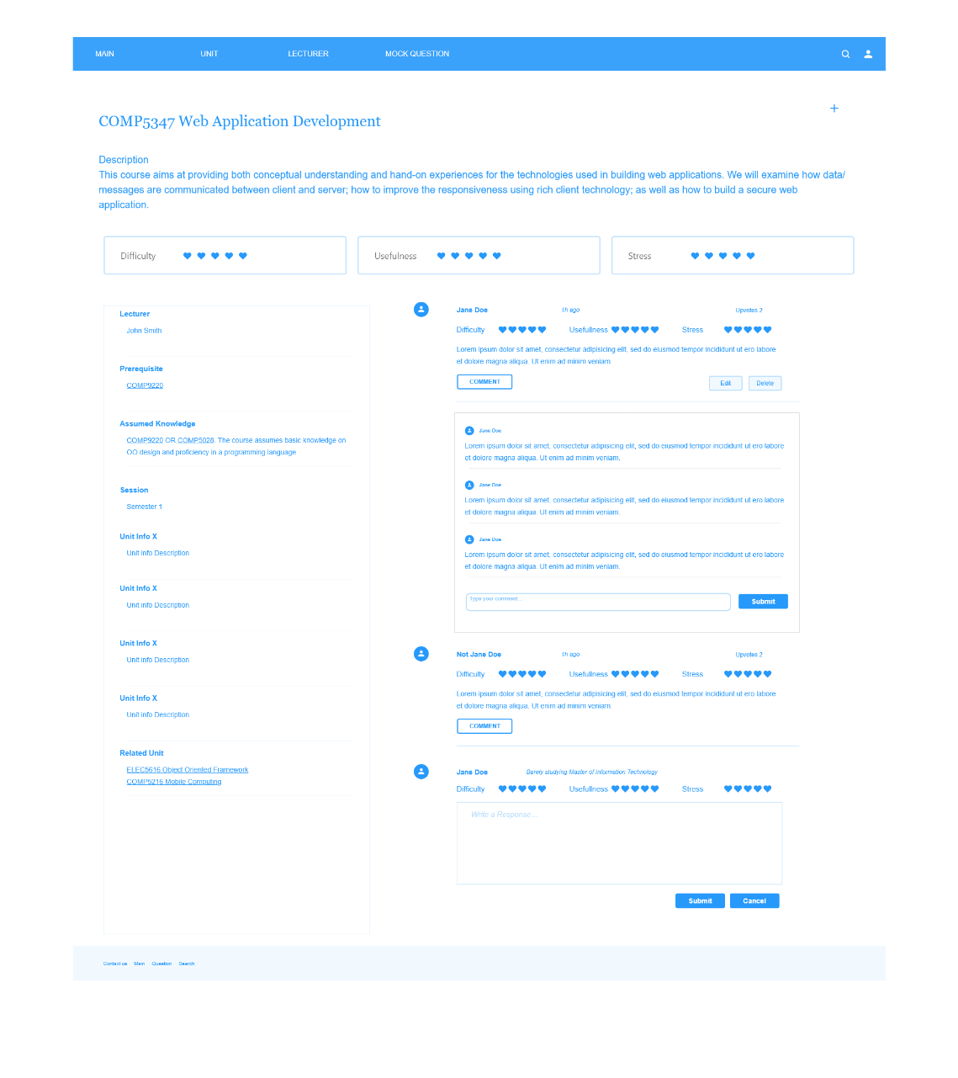

# Data Entities

## Unit Information

|  |  |  |
| --- | --- | --- |
| Unit ID | String | Unique UUID |
| Unit Code | String | Unique COMP5347 |
| Unit Name | String | Web Application Development |
| Unit Mode | ENUM Strings | "Normal-Day", "Normal-Evening", … |
| Faculty/School | String | School of Information Technologies |
| Unit Coordinator/s | (String, String) | COMPOSITE ATTRIBUTE: (Last Name, First Name)("Suleiman, Basem", …) |
| Session options | ENUM Strings | "Semester 1", "Summer Early", … |
| Pre-Requisites | String | COMP9220 |
| Brief Handbook Description | String | At the end of this course, students are expected to have a clear understanding of the structure and technologies of web applications. |
| Prerequisite Units | String [] | ["COMP9220 ", "COMP5028" ] |
| Assumed Knowledge Units | String [] | ["COMP9220 ", "COMP5028" ] |
| Assumed Knowledge Text | String | COMP9220 OR COMP5028. The course assumes basic knowledge on OO design and proficiency in a programming language |
| Assessment Methods | ?? | ?? |
| Difficulty | double | Derived attribute |
| Usefulness | double | Derived attribute |
| Stress | double | Derived attribute |

* Anonymous user + IP

## Unit Review

|  |  |  |
| --- | --- | --- |
| Review ID | String | Unique UUID |
| Review Semester | String + Integer |  |
| Review | String | This unit is ok. |
| Difficulty | int | 1-5 |
| Usefulness | int | 1-5 |
| Stress | int | 1-5 |
| Upvotes | int |  |
| Timestamp | Date | Date Object |

## Lecturer*

|  |  |  |
| --- | --- | --- |
| Lecturer ID | String | Unique UUID |
| Lecturer Name | (String, String) | COMPOSITE ATTRIBUTE: (Last Name, First Name)("Suleiman, Basem", …) |
| Rating | int | Derived attribute |
| Upvotes | int |  |
| Teaching Commitment/History | [(String, String, String)] | Composite Multivalued?; COMP5347, XXXX , Semester 1 |
| Contact Email | String | asm@gmail.com |

## Lecturer Review

|  |  |  |
| --- | --- | --- |
| Review ID | String | Unique UUID |
| Review Semester | ENUM Strings | Semester 1 |
| Review Year | Date | 2001 |
| Difficulty | int | 1-5 |
| Usefulness | int | 1-5 |
| Stress | int | 1-5 |
| Upvotes | int |  |
| Timestamp | Date | 2001-1-1 |